CISC 3595 Operating Systems

Fall 2022

Assignment

Out 11/20, In 11/29

Q1. For each of the following Resource Allocation graphs, use the Graph Reduction algorithm described in the lectures to determine the following: (30 pts total)

1. List a possible order in which vertices are removed from the graph (3 pts each)
2. Is there a deadlock? (2 pts each)

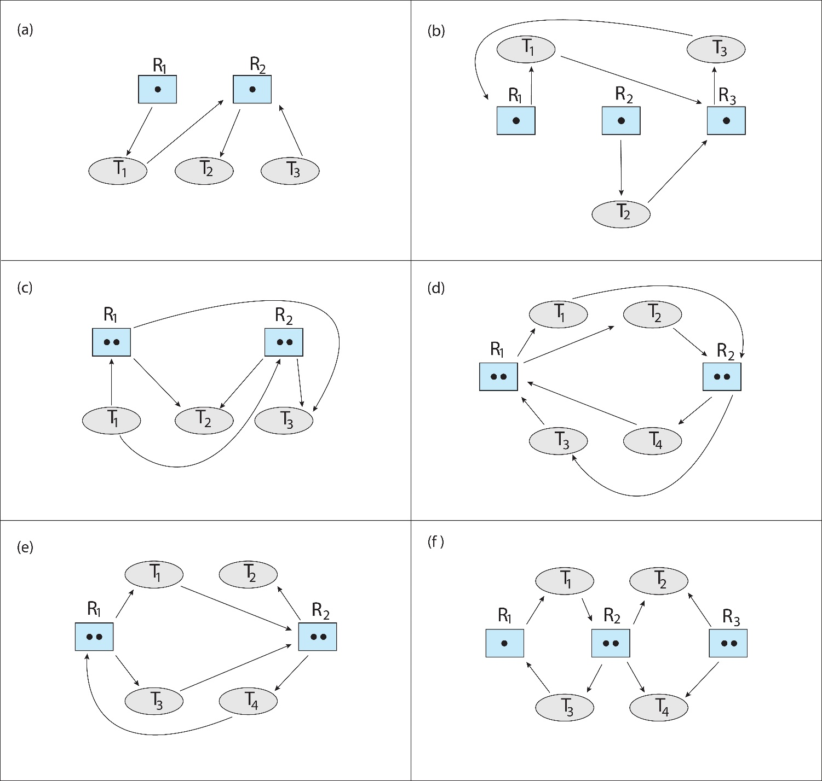

Q2. Consider the following system allocation matrix with accompanying maximum requirements of each thread for each resource. (20 pts total)

1. fill in the Need matrix for each scenario (4 pts each)
2. Is the scenario safe? (2 pts each)
3. List the order in which the threads can complete or show where the allocation cannot be satisfied. (2 pts each)

Available = (0,3,0,1)

Available = (1,0,0,2)

|  |  |  |  |  |  |  |  |  |  |  |  |  |  |  |  |  |  |  |  |  |  |  |  |  |  |  |  |  |  |  |  |  |  |  |  |  |  |  |  |  |  |  |  |  |  |  |  |  |  |  |  |  |  |  |  |  |  |  |  |  |  |  |  |  |  |  |  |  |  |  |  |  |  |  |  |  |  |  |  |  |  |  |  |  |  |  |  |  |  |  |  |  |  |  |
| --- | --- | --- | --- | --- | --- | --- | --- | --- | --- | --- | --- | --- | --- | --- | --- | --- | --- | --- | --- | --- | --- | --- | --- | --- | --- | --- | --- | --- | --- | --- | --- | --- | --- | --- | --- | --- | --- | --- | --- | --- | --- | --- | --- | --- | --- | --- | --- | --- | --- | --- | --- | --- | --- | --- | --- | --- | --- | --- | --- | --- | --- | --- | --- | --- | --- | --- | --- | --- | --- | --- | --- | --- | --- | --- | --- | --- | --- | --- | --- | --- | --- | --- | --- | --- | --- | --- | --- | --- | --- | --- | --- | --- | --- | --- |
| |  | | --- | |  | | Thread | | T0 | | T1 | | T2 | | T3 | | T4 | | |  |  |  |  | | --- | --- | --- | --- | | Max | | | | | A | B | C | D | | 5 | 1 | 1 | 7 | | 3 | 2 | 1 | 1 | | 3 | 3 | 2 | 1 | | 4 | 6 | 1 | 3 | | 6 | 3 | 2 | 5 | | |  |  |  |  | | --- | --- | --- | --- | | Allocated | | | | | A | B | C | D | | 3 | 0 | 1 | 4 | | 2 | 2 | 1 | 0 | | 3 | 1 | 2 | 1 | | 0 | 5 | 1 | 0 | | 4 | 2 | 1 | 2 | | |  |  |  |  | | --- | --- | --- | --- | | Need | | | | | A | B | C | D | |  |  |  |  | |  |  |  |  | |  |  |  |  | |  |  |  |  | |  |  |  |  | |

Available = (1,5,2,0)

|  |  |  |  |  |  |  |  |  |  |  |  |  |  |  |  |  |  |  |  |  |  |  |  |  |  |  |  |  |  |  |  |  |  |  |  |  |  |  |  |  |  |  |  |  |  |  |  |  |  |  |  |  |  |  |  |  |  |  |  |  |  |  |  |  |  |  |  |  |  |  |  |  |  |  |  |  |  |  |  |  |  |  |  |  |  |  |  |  |  |  |  |  |  |  |
| --- | --- | --- | --- | --- | --- | --- | --- | --- | --- | --- | --- | --- | --- | --- | --- | --- | --- | --- | --- | --- | --- | --- | --- | --- | --- | --- | --- | --- | --- | --- | --- | --- | --- | --- | --- | --- | --- | --- | --- | --- | --- | --- | --- | --- | --- | --- | --- | --- | --- | --- | --- | --- | --- | --- | --- | --- | --- | --- | --- | --- | --- | --- | --- | --- | --- | --- | --- | --- | --- | --- | --- | --- | --- | --- | --- | --- | --- | --- | --- | --- | --- | --- | --- | --- | --- | --- | --- | --- | --- | --- | --- | --- | --- | --- |
| |  | | --- | |  | | Thread | | T0 | | T1 | | T2 | | T3 | | T4 | | |  |  |  |  | | --- | --- | --- | --- | | Max | | | | | A | B | C | D | | 0 | 0 | 1 | 2 | | 1 | 7 | 5 | 0 | | 2 | 3 | 5 | 6 | | 0 | 6 | 5 | 2 | | 0 | 6 | 5 | 6 | | |  |  |  |  | | --- | --- | --- | --- | | Allocated | | | | | A | B | C | D | | 0 | 0 | 1 | 2 | | 1 | 0 | 0 | 0 | | 1 | 3 | 5 | 4 | | 0 | 6 | 3 | 2 | | 0 | 0 | 1 | 4 | | |  |  |  |  | | --- | --- | --- | --- | | Need | | | | | A | B | C | D | |  |  |  |  | |  |  |  |  | |  |  |  |  | |  |  |  |  | |  |  |  |  | |

Q3. In chapter 14.4, File Allocation Schemes are discussed. Assuming that the storage device is represented as a linear list of blocks at the lowest physical layer, the I/O control converts a block number to a physical address. We’re interested in converting a logical address to a block number. *Explain* how *Logical Addresses* are mapped to *Physical Addresses* for each of

1. contiguous allocation,
2. linked allocation
3. indexed allocation
4. FAT approaches for representing files.

by showing for each approach how to calculate the physical address from the logical address and how to navigate to the block using the examples addresses 4209, 3034, 262, 18176, for a system with block size 512. (2 pts each – 32 points)

Q4. Consider a file system that uses a modified contiguous-allocation scheme with support for extents. A file is a collection of extents, with each extent corresponding to a contiguous set of blocks. A key issue in such systems is the degree of variability in the size of the extents. Assuming internal fragmentation means that allocated blocks are not completely used and external fragmentation means that contiguous unallocated blocks are not enough for any file,

what are the advantages and disadvantages of the following schemes? (18 pts)

1. All extents are of the same size, and the size is predetermined.
2. Extents can be of any size and are allocated dynamically.
3. Extents can be of a few fixed sizes, and these sizes are predetermined.