**CISC 4090 Homework 1**

**(100 points total)**

Note: according to our book on page 4, the set of natural numbers N does not include 0.

Question 1: (16 points) Examine the following “set-builder” descriptions of the following sets, and provide a list of set members. For full credit your members should show you capture the full diversity and range of the possible elements. Be especially careful for 1c.

Example “builder” description: {*y* | *y*=3*x* and $x∈N$}

Example answer: {3, 6, 9, 12, … }

1. {5*m* | and *m>5*}
2. { | }
3. {*w* | *w* is a string over the alphabet consisting of As and Bs, and *w* is a palindrome (reads the same forward and in reverse)}

1. {(*y*, *y*-2) | }

Question 2: (15 points) Provide a “set-builder” description (see Question 1) for each of the sets with elements listed below.

1. {10, 100, 1000, 10000, …}
2. {1, 4, 7, 10, 13, …}
3. {3, 4, 5, 6, 7, 8, …}
4. {1,2,3,4,5,6}
5. {}

Question 3: (20 points)

Let A={ab, aabb, aaabbb, aaaabbbb}, B={ab, abab, ababab}, and C={ab, aabb}

1. $C⊆A$ (circle one) True False
2. $B⊆A$ (circle one) True False
3. What is $B∪C$?
4. What is $A∩B$?
5. What is the power set of C?

Question 4: (10 points)

1. Given an arbitrary set A, with a total of |A| elements, how many elements are in the power set of A?

1. Given an arbitrary set A and B with |A| and |B| elements respectively, how many elements are in the “Cartesian product” of the two sets-- $A×B$?

Question 5: (8 points) Let *X* be the set {2, 4, 6, 8, 10} and Y be the set {1, 2, 3, 4, 5}. The unary function $f:X→Y$ and the binary function $g:X×Y→X$ are described in the following tables.

|  |  |  |  |  |  |  |  |  |  |  |  |  |  |  |  |  |  |  |  |  |  |  |  |  |  |  |  |  |  |  |  |  |  |  |  |  |  |  |  |  |  |  |  |  |  |  |  |  |  |  |
| --- | --- | --- | --- | --- | --- | --- | --- | --- | --- | --- | --- | --- | --- | --- | --- | --- | --- | --- | --- | --- | --- | --- | --- | --- | --- | --- | --- | --- | --- | --- | --- | --- | --- | --- | --- | --- | --- | --- | --- | --- | --- | --- | --- | --- | --- | --- | --- | --- | --- | --- |
| |  |  | | --- | --- | | *n* | *f*(*n*) | | 2 | 3 | | 4 | 3 | | 6 | 5 | | 8 | 5 | | 10 | 1 | |  | |  |  |  |  |  |  | | --- | --- | --- | --- | --- | --- | | *g* | 1 | 2 | 3 | 4 | 5 | | 2 | 4 | 4 | 4 | 4 | 4 | | 4 | 6 | 6 | 6 | 10 | 10 | | 6 | 10 | 8 | 6 | 4 | 2 | | 8 | 2 | 2 | 6 | 6 | 6 | | 10 | 4 | 8 | 10 | 8 | 4 | |

1. What is the value of *f*(8)?
2. What are the range and domain of *f*?
3. What is the value of *g*(8,4)?
4. What is the value of *f*(*g*(6,5))?

Question 6: (12 points) Consider the undirected graph *G*=(*V*,*E*) where *V*, the set of nodes, is {1, 2, 3, 4} and *E*, the set of edges, is {{1,2}, {1,3}, {2,3}, {3,4}}.

1. Draw the graph *G*.

1. What are the degrees of each node?
2. Write a set of edges forming a path from node 3 to node 4 in the graph.

Question 7: (9 points) Write a formal description of the following graph.

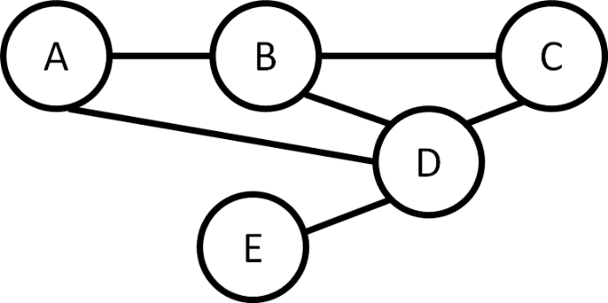

Question 8: (10 points) Show that every graph with two or more nodes contains at least two nodes that have equal degrees.

Notes:

* We do not allow an edge from a node to itself.
* The graph does not have to be connected (some nodes may not have any edges)

*Big Hint: Think of the pigeonhole principle, possibly taught in CISC 1100/1400. Feel free to look it up.*