Web-Based Architecture Diagrams

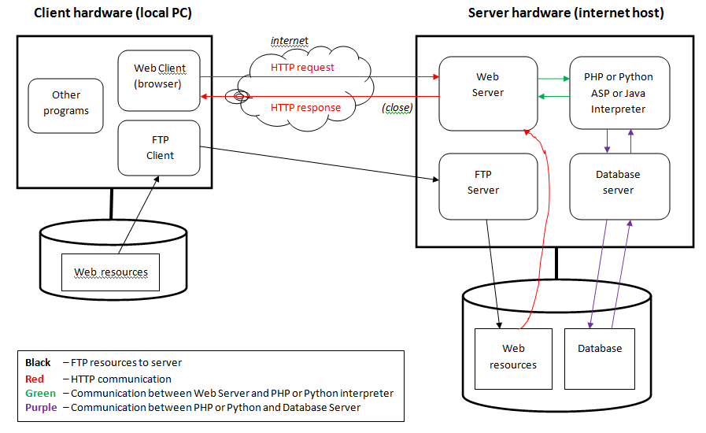

Explanation of Above Diagram

- A web resource (an html page, an image, an audio/video component, an external JavaScript or CSS file, etc.) is developed and approved on the client side (PC or Mac)

- The component is moved (through FTP) to the server, and placed on disk.

- A browser is launched and makes a request to access that component from the web server. The URL is translated to a file location on the server disk.

- The web server reads the component from its disk, and if the component is static (e.g. html, css, image, audio/video, etc.) delivers (a copy of) the component as is to the browser for rendering.

- If on the other hand the component is a program (e.g. a search form, or an order form, etc.) it is mostly a program written in PHP, Python, Java, etc. Upon retrieving the component from disk, the web server sends the component to the appropriate interpreter for proper execution.

- The interpreter (be it PHP or Python interpreter, or Java application server) executes the program and sends the output of that program (which should mostly be html) to the web server. The web server will in turn send it back to the browser.

- If the program needs to access a database, the program contacts the database server. The database server either reads (or writes) the data from/to the physical database, and returns it to the program.

- When the web server completes its response, it closes the TCP/IP communication link to the client.

